**Lesson 8 Cíntia Domingos**

**Level 1**

**1.** Answer C: 49, 50, 54, 55, 60, 62

Equivalence classes:

[0, 50]: 49 is just below the boundary value; 50 is the boundary value

]50, 55[: 54 is just below the boundary value, 55 is the boundary value

[55, 60[: 60 is the boundary value

[60, +∞[: 62 just above the boundary value

**2.**

Answer D: 666, 999, 2222, 5555, 6666

This data set is the only one of the options that covers 4 equivalence classes, the others only cover 3.

**Level 2**

**2.**

|  |  |
| --- | --- |
| Time in the sun | Intensity |
| < 3 hours | Very low |
| 3 – 6 hours | Low |
| > 6 hours | Medium |
| ------------ | High |

|  |  |  |
| --- | --- | --- |
| Test Case | Time in the sun | Intensity |
| TC 1 | < 3 hours | Very low |
| TC 2 | > 6 hours | Medium |
| TC3 | < 3 hours | Very low |

Answer B. We need two more test cases:

TC4: 3-6 hours with low intensity

TC5: any number of hours, high intensity

**3.**

As mentioned during the lesson, I believe the best option is C, 4 test cases, one for each resolution, to test all the values.

After some research (<https://en.wikipedia.org/wiki/Graphics_display_resolution>), I came up with these classes:

|  |  |  |
| --- | --- | --- |
| Aspect Ratio (class) | Low | High |
| 4:3 | 640x480 | 1600x1200 |
| 16:9 | 1280x720 | 1920x1080 |

I believe it could be possible to test only for 1600x1200 and 1920x1080, because if an app can play a 1600x1200 or 1920x1080 resolution video, it should be able to play smaller videos as well.

The exercise does not have that option, which leads me once again to answer C: 1 test case for the lower and upper limit in each class and also because none of the other options cover the 1600x1200 resolution (1200 px height).

A screen with 1920x1200 would cover every class (<https://dewt.org/posts/crispy-pixels-and-the-golden-ratio/>), but there is no such option on the exercise.

**Level 3**

**2. RQ1:** The minimum resolution of photos the users can upload to the system is 180x180 px.

|  |  |  |  |
| --- | --- | --- | --- |
| **Parameter** | **Boundary** | **Exemplar** | **Expected** |
| Min Width x Height | 180x180 | 180x180 | Pass |
|  |  | 179x179 | Fail |
|  |  | 181x181 | Pass |

|  |  |  |  |  |  |  |  |  |
| --- | --- | --- | --- | --- | --- | --- | --- | --- |
| **Test Case** | **Title** | **Pre-conditions** | | **Steps** | | **Expected result** | | |
| **TC1** | Upload a picture with 180x180 px | You are logged in a valid account;  Environment: iOS 17.3, Android 14 | | 1. On the main page, tap the button “Upload picture”. | | The gallery is opened. | | |
|  |  |  | | 2. Tap a picture with 180x180 px to upload. | | The picture is selected. | | |
|  |  |  | | 3. Tap the button “OK”. | | The app is shown loading the picture. | | |
|  |  |  | | Wait for the upload to finish. | | The success message “Your picture has been uploaded!” is displayed. The picture is shown on the user profile. | | |
| **Test Case** | | **Title** | | **Pre-conditions** | | **Steps** | | **Expected result** |
| **TC2** | | Upload a picture with 181x181 px | | You are logged in a valid account;  Environment: iOS 17.3, Android 14 | | 1. On the main page, tap the button “Upload picture”. | | The gallery is opened. |
|  | |  | |  | | 2. Tap a picture with 181x181 px to upload. | | The picture is selected. |
|  | |  | |  | | 3. Tap the button “OK”. | | The app is shown loading the picture. |
|  | |  | |  | | Wait for the upload to finish. | | The success message “Your picture has been uploaded!” is displayed. The picture is shown on the user profile. |

|  |  |  |  |  |
| --- | --- | --- | --- | --- |
| **Test Case** | **Title** | **Pre-conditions** | **Steps** | **Expected result** |
| **TC3** | Upload a picture with 179x179 px | You are logged in a valid account;  Environment: iOS 17.3, Android 14 | 1. On the main page, tap the button “Upload picture”. | The gallery is opened. |
|  |  |  | 2. Tap a picture with 179x179 px to upload. | The picture is selected. |
|  |  |  | 3. Tap the button “OK”. | The app is shown loading the picture. |
|  |  |  | Wait for the upload to finish. | The error message “Wrong size! Please upload a picture with at least 180x180 px.” is displayed. |

**RQ2:** The maximum resolution of photos the users can upload to the system is 1080x1080 px.

|  |  |  |  |
| --- | --- | --- | --- |
| Max Width x Height | 1080x1080 | 1080x1080 | Pass |
|  |  | 1079x1079 | Pass |
|  |  | 1081x1081 | Fail |

|  |  |  |  |  |
| --- | --- | --- | --- | --- |
| **Test Case** | **Title** | **Pre-conditions** | **Steps** | **Expected result** |
| **TC4** | Upload a picture with 1080x1080 px | You are logged in a valid account;  Environment: iOS 17.3, Android 14 | 1. On the main page, tap the button “Upload picture”. | The gallery is opened. |
|  |  |  | 2. Tap a picture with 1080x1080 px to upload. | The picture is selected. |
|  |  |  | 3. Tap the button “OK”. | The app is shown loading the picture. |
|  |  |  | Wait for the upload to finish. | The success message “Your picture has been uploaded!” is displayed. The picture is shown on the user profile. |

|  |  |  |  |  |
| --- | --- | --- | --- | --- |
| **Test Case** | **Title** | **Pre-conditions** | **Steps** | **Expected result** |
| **TC5** | Upload a picture with 1079x1079 px | You are logged in a valid account;  Environment: iOS 17.3, Android 14 | 1. On the main page, tap the button “Upload picture”. | The gallery is opened. |
|  |  |  | 2. Tap a picture with 1079x1079 px to upload. | The picture is selected. |
|  |  |  | 3. Tap the button “OK”. | The app is shown loading the picture. |
|  |  |  | Wait for the upload to finish. | The success message “Your picture has been uploaded!” is displayed. The picture is shown on the user profile. |

|  |  |  |  |  |
| --- | --- | --- | --- | --- |
| **Test Case** | **Title** | **Pre-conditions** | **Steps** | **Expected result** |
| **TC6** | Upload a picture with 1081x1081 px | You are logged in a valid account;  Environment: iOS 17.3, Android 14 | 1. On the main page, tap the button “Upload picture”. | The gallery is opened. |
|  |  |  | 2. Tap a picture with 1081x1081 px to upload. | The picture is selected. |
|  |  |  | 3. Tap the button “OK”. | The app is shown loading the picture. |
|  |  |  | Wait for the upload to finish. | The error message “Wrong size! Please upload a picture with maximum 1080x1080 px.” is displayed. |

A more thorough way to test would be using pairwise testing with the following values:

Width: 179, 180, 181, 1079, 1080, 1081

Height: 179, 180, 181, 1079, 1080, 1081

which results in 36 different pairs, each requiring its own test case.

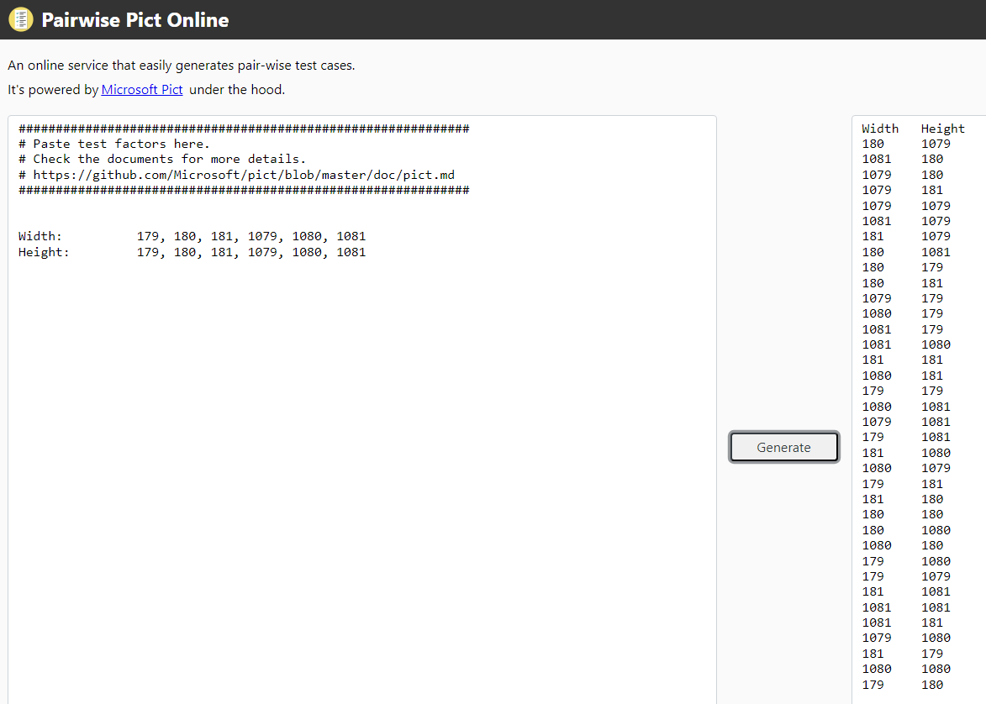

|  |  |  |  |
| --- | --- | --- | --- |
| **Parameter** | **Class** | **Exemplar** | **Expected** |
| Length of comments | [2, 500] | 300 | Pass |
|  | [501, +∞[ | 750 | Fail |
|  | [0, 1] | 1 | Fail |

**RQ3:** The length of comments under photos must be between 2 and 500 characters.

|  |  |  |  |  |
| --- | --- | --- | --- | --- |
| **Test Case** | **Title** | **Pre-conditions** | **Steps** | **Expected result** |
| **TC7** | Insert a comment with 300 characters | You are logged in a valid account; The account has at least 1 picture;  Environment: iOS 17.3, Android 14 | 1. Open the page for a picture. | The page is opened. |
|  |  |  | 2. In the comment box, type 300 characters. | The 300 characters are displayed in the comment box. |
|  |  |  | 3. Tap the button “Send”. | The comment is posted under the picture. The success message “Comment sent.” is displayed above the comment box. |

|  |  |  |  |  |  |  |  |
| --- | --- | --- | --- | --- | --- | --- | --- |
| **Test Case** | | **Title** | **Pre-conditions** | | **Steps** | **Expected result** | |
| **TC8** | | Insert a comment with 750 characters | You are logged in a valid account; The account has at least 1 picture;  Environment: iOS 17.3, Android 14 | | 1. Open the page for a picture. | The page is opened. | |
|  | |  |  | | 2. In the comment box, type 750 characters. | The 750 characters are displayed in the comment box. | |
|  | |  |  | | 3. Tap the button “Send”. | The error message “Insert a comment with 2 – 500 characters.” is displayed above the comment box. The comment is not posted. | |
| **Test Case** | **Title** | | **Pre-conditions** | **Steps** | | **Expected result** | |
| **TC9** | Insert a comment with 1 character | | You are logged in a valid account; The account has at least 1 picture;  Environment: iOS 17.3, Android 14 | 1. Open the page for a picture. | | The page is opened. | |
|  |  | |  | 2. In the comment box, type 1 character. | | The character is displayed in the comment box. | |
|  |  | |  | 3. Tap the button “Send”. | | The error message “Insert a comment with at least 2 characters.” is displayed above the comment box. The comment is not posted. | |

RQ4: Depending on the number of total likes in their pictures, the users get a level tag in their profile:

Level 1: 0 likes – Newbie Kitten

Level 2: 10 likes – Feline Novice

Level 3: 50 likes – Whiskered Expert

Level 4: 100 likes – Clawed Meowster

Level 5: 200 likes – Panther Sensei

Level 6: 350 likes – Purrfectly Pawtastic

Level 7: 500 likes – King of the Jungle

Equivalence classes:

|  |  |  |  |
| --- | --- | --- | --- |
| **Parameter** | **Class** | **Exemplar** | **Expected** |
| Total likes | [0, 9] | 8 | Newbie Kitten |
|  | [10, 49] | 48 | Feline Novice |
|  | [50, 99] | 51 | Whiskered Expert |
|  | [100, 199] | 199 | Clawed Meowster |
|  | [200, 349] | 348 | Panther Sensei |
|  | [350, 499] | 351 | Purrfectly Pawtastic |
|  | [500, +∞[ | 501 | King of the Jungle |

Example of test case:

|  |  |  |  |  |
| --- | --- | --- | --- | --- |
| **Test Case** | **Title** | **Pre-conditions** | **Steps** | **Expected result** |
| **TC10** | Check the “Newbie Kitten” tag | You are logged in a valid account with 8 total likes in the account’s pictures.  Environment: iOS 17.3, Android 14 | 1. On the main page, tap the “User Profile” button. | The User Profile page is opened. |
|  |  |  | 2. Check the tag under the profile picture. | The tag is “Newbie Kitten”. |

Repeat the test case for every level.